Microsoft Intune Configuration Profiles
Architect Edition: Zero-to-Advanced Master SOP
Settings Catalog | Templates | ADMX | Custom OMA-URI | Browser | OneDrive | Wi-Fi | Reports | Architecture
Purpose
A deeply explained, screenshot-based architecture and operations guide. Each screenshot is expanded with what the screen shows, why the feature is used, how to configure it, real-world examples, design choices, common mistakes, validation, and troubleshooting. This replaces a screenshot-only reference with a practical knowledge base.

Document field | Value
Owner | Endpoint Management / IT Operations
Platform | Microsoft Intune
Topics | Windows Configuration Profiles, Settings Catalog, ADMX, Templates, Custom Profiles
Source screenshots | Configuration Profiles.docx
Edition | Architect Edition 1.1
Prepared date | 25 September 2026
Classification | Internal use

Executive Summary
Architecture, operations, and governance at a glance
Microsoft Intune configuration profiles apply managed settings through Settings Catalog, purpose-built templates, imported ADMX, and Custom OMA-URI. The recommended design is to use the most native supported policy surface, maintain one authoritative owner for each setting family, deploy through controlled rings, validate actual endpoint behavior, and keep a tested rollback path.

Executive priorities
Priority | Required control
Standardize | Use approved profile types, naming convention, ownership, versions, and policy records
Reduce risk | Lab and pilot first; prevent overlap; separate high-risk settings and rollback domains
Validate | Check local endpoint behavior, dependencies, user impact, and portal reporting
Operate | Monitor errors, conflicts, certificate expiry, encryption readiness, and stale assignments

Architecture decision flow
Requirement | → | Native policy surface | → | Pilot | → | Phased rollout | → | Validate | → | Retire/replace

Mandatory architect decisions
- Prefer Settings Catalog when the required Windows setting is available.
- Use workload templates for Wi-Fi, VPN, certificates, Domain Join, and supported Custom scenarios.
- Use imported ADMX only for trusted settings that are not available natively, with dependencies reviewed first.
- Use Custom OMA-URI only when path, scope, data type, supported editions, value, and rollback are documented.
- Prevent overlap across Settings Catalog, Endpoint security, baselines, GPO, browser-cloud management, imported ADMX, and Custom CSP policies.
Executive control point
Succeeded confirms policy processing, not the intended business outcome. Production acceptance requires endpoint validation, dependency testing, user-impact review, and monitoring evidence.

1. Configuration Profiles Fundamentals

1.1 What a configuration profile is
A configuration profile is a collection of device or user settings that Intune delivers to managed endpoints. A profile can configure Windows features, browsers, security options, Wi-Fi, VPN, certificates, OneDrive, restrictions, and application preferences. The profile is assigned to Microsoft Entra groups and processed by the device through MDM or related management channels.

1.2 Processing flow
Author policy | → | Assign group | → | Device checks in | → | CSP/ADMX applies | → | Device reports status | → | Admin validates

1.3 Configuration vs compliance vs endpoint security
Area | Primary purpose | Example
Configuration profile | Apply a setting | Enable OneDrive silent sign-in
Compliance policy | Evaluate state | Require encryption or minimum OS
Endpoint security policy | Apply security-focused configuration | Configure BitLocker or Firewall
Security baseline | Apply a Microsoft-recommended bundle | Windows or Edge baseline
Application policy | Install/configure application content | Deploy Chrome/Zoom app

1.4 Architectural layers
Layer | Role
Intune policy object | Stores settings, assignments, scope tags, filters
Microsoft Entra group | Defines targeted users/devices
MDM/CSP or ADMX channel | Translates policy to Windows configuration
Device registry/configuration store | Holds effective local state
Reporting | Shows assignment and setting results
Operations | Investigates conflicts, errors, and lifecycle
Key principle
A policy showing Succeeded means Intune processed the profile. Always validate the actual device behavior, particularly for browser, OneDrive, certificate, Wi-Fi, and Custom OMA-URI settings.

2. Choose the Correct Profile Type
Profile type | Use when | Preferred position
Settings Catalog | The required setting is available in the unified catalog | First choice for new Windows policies
Template | A purpose-built template exists, such as Wi-Fi, VPN, Domain Join, or Custom | Use when the template matches the scenario
Administrative Templates in Settings Catalog | Managing ADMX-backed Windows/application settings | Use the unified Settings Catalog experience
Imported ADMX | A trusted third-party setting is unavailable natively | Use after dependency and vendor review
Custom OMA-URI | A supported CSP setting is unavailable in catalog/template | Last-resort expert option
Endpoint security policy | Security workload is available under Endpoint security | Prefer for security ownership and reporting

2.1 Decision flowchart
Search Settings Catalog | → | Check template | → | Check imported ADMX | → | Validate CSP | → | Use Custom OMA-URI

2.2 Do not choose Custom first
- Settings Catalog provides searchable metadata, supported values, and clearer reporting.
- Templates reduce typing and path errors.
- Imported ADMX can present vendor policy settings in the portal.
- Custom OMA-URI requires exact CSP path, data type, value, scope, and edition support.

3. Navigate to Configuration Profiles
Exact portal path
Microsoft Intune admin center > Devices > Configuration

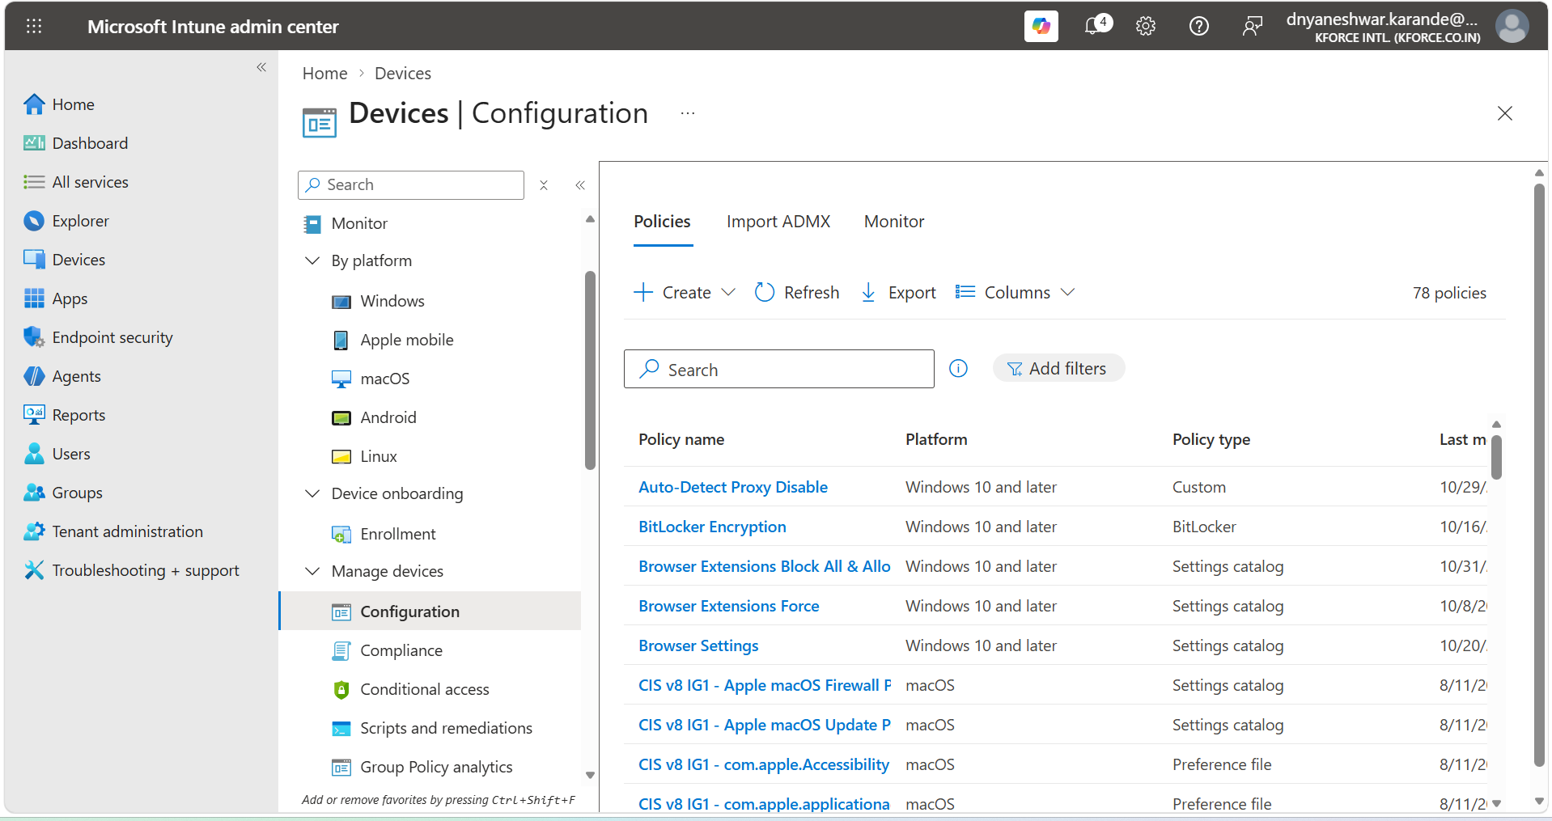
Figure 1. Devices > Configuration overview. This is the central workspace for policies, ADMX import, monitoring, encryption, certificates, assignment failures, and restricted-app reports.

3.1 What this screen is used for
- Create and manage device configuration policies.
- Import approved ADMX/ADML templates.
- Open operational reports.
- Review encryption and certificate inventory.
- Investigate assignment failures.
- Review restricted app detections.
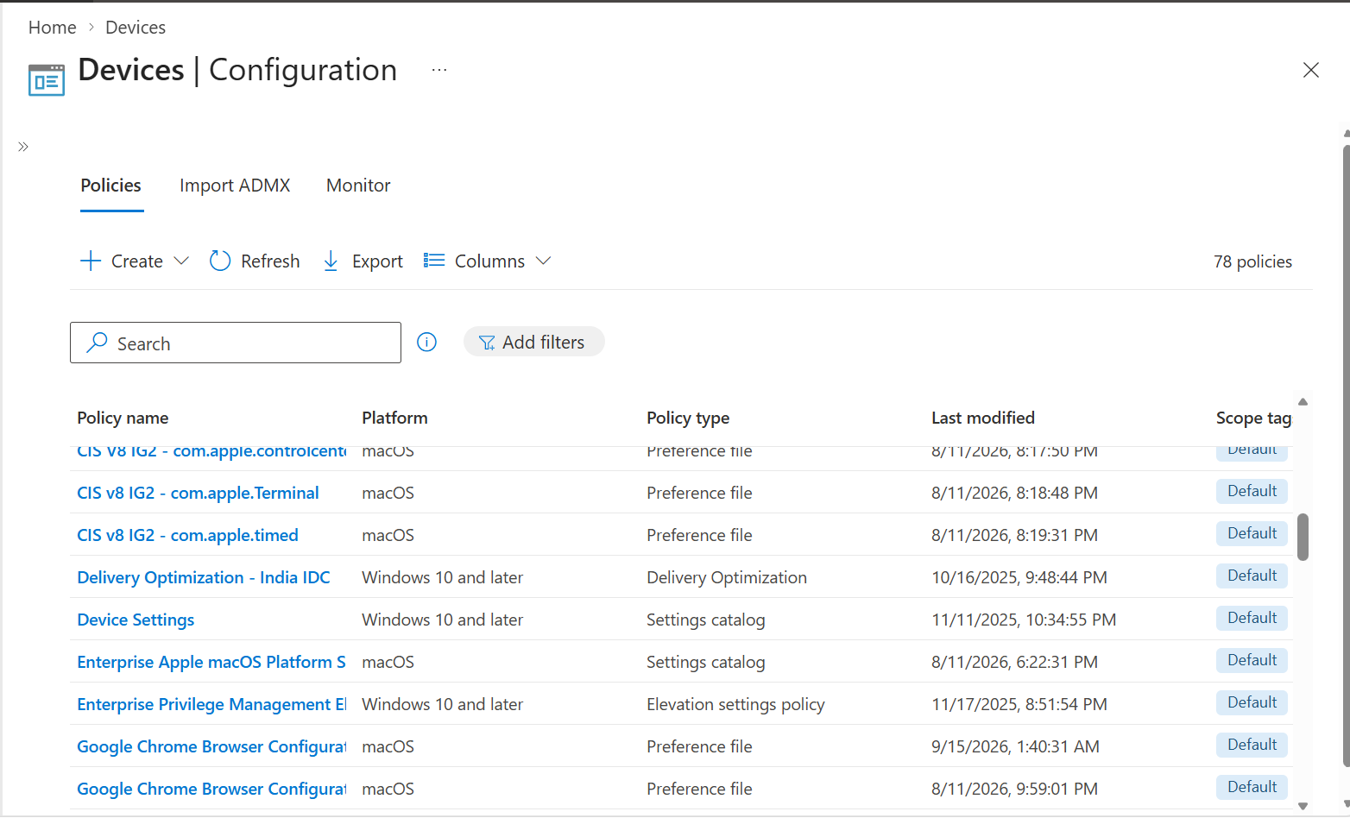
Figure 2. Configuration navigation from Devices and platform pages.

3.2 Architect interpretation
The Configuration workspace is not only a policy list. It is the operational center for policy lifecycle: design, creation, assignment, monitoring, failure analysis, encryption posture, and certificate visibility. An architect should link every profile to an owner and a validation report.

4. Policy Inventory and Imported ADMX
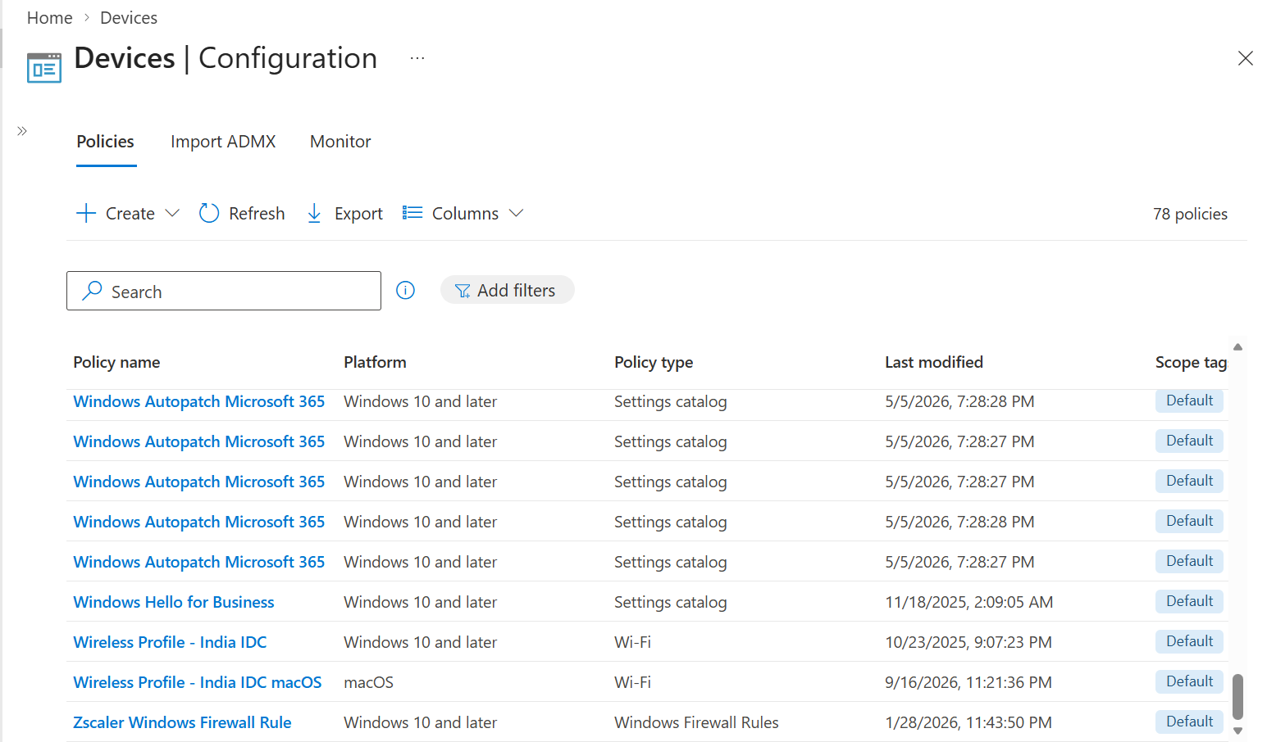
Figure 3. Policies, Import ADMX, and Monitor tabs with Create, Refresh, and Export actions.
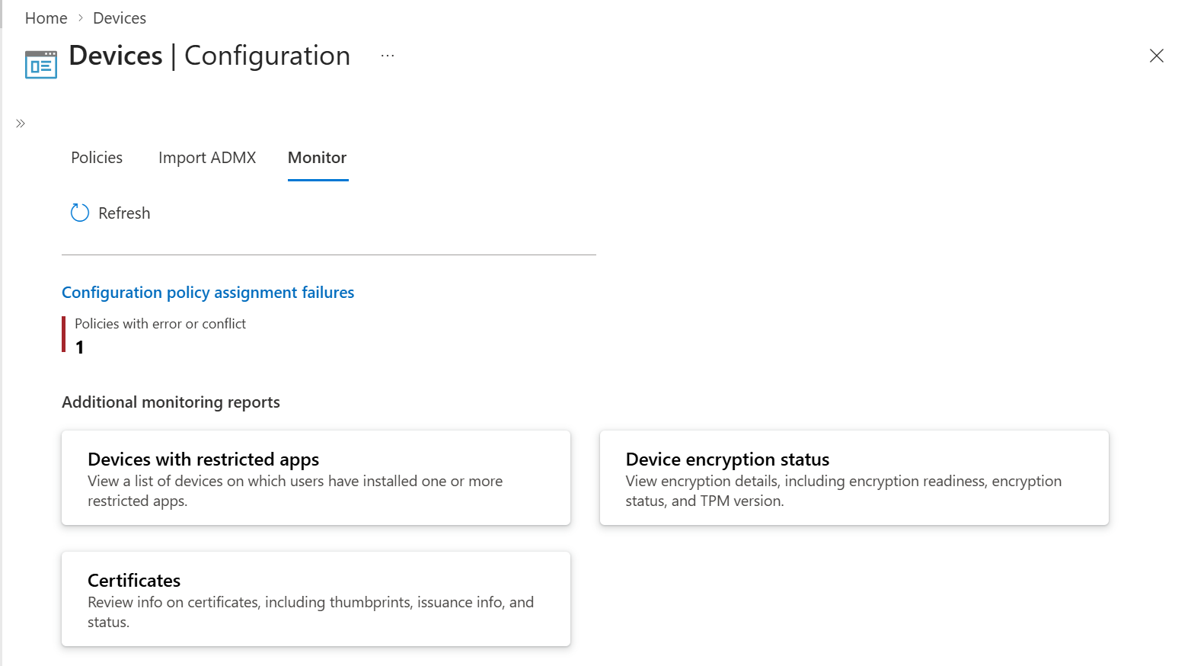
Figure 4. Import ADMX inventory and administrative-template management area.

4.1 Policy inventory procedure
- Open Policies.
- Export the policy list before major redesign or migration.
- Record name, platform, profile type, assignments, last modified date, and owner.
- Identify duplicates and legacy Administrative Templates.
- Map each profile to business purpose and support team.
- Do not delete a policy until replacement behavior is validated.

4.2 Import ADMX procedure
Exact portal path
Microsoft Intune admin center > Devices > Configuration > Import ADMX > Import

- Download ADMX and matching en-US ADML from the trusted vendor.
- Open the ADMX in a text editor and identify namespace dependencies.
- Import dependency files first.
- Select ADMX and ADML files.
- Add a clear description and upload.
- Wait until Status is Available.
- Create a Settings Catalog profile and locate the imported Administrative Template settings.
- Pilot before production.

4.3 Current Microsoft limitations
Microsoft documents imported ADMX/ADML as a Windows feature in public preview. Microsoft states a maximum of 20 ADMX files, each ADMX up to 1 MB, one ADML per ADMX, and en-US as the supported language. Dependencies must be imported first.
Current platform change
Microsoft states the older Templates > Administrative Templates profile type became deprecated and read-only starting with the December 2412 release. Build new ADMX-backed Windows policies through Settings Catalog and plan controlled migration of legacy profiles.

5. Create a Settings Catalog Profile from Scratch
Exact portal path
Microsoft Intune admin center > Devices > Configuration > Create > New policy

5.1 Platform and profile type
- Set Platform to Windows 10 and later.
- Set Profile type to Settings catalog.
- Select Create.
- On Basics, enter a unique Name.
- Enter a Description with owner, purpose, scope, version, ticket, and risk.
- Select Next.

5.2 Select settings
- Select Add settings.
- Search by plain-language keyword, CSP family, or Administrative Templates category.
- Open setting help text and confirm supported editions and scope.
- Select only settings required for this policy.
- Close the picker.
- Configure each setting value.
- Remove accidental duplicate or conflicting settings.

5.3 Scope tags and assignments
- Apply Scope tags if help-desk or regional RBAC requires them.
- Assign to a small pilot group first.
- Use device groups for device-scoped settings and user groups for user-scoped settings.
- Use assignment filters only with documented include/exclude logic.
- Review included and excluded groups.

5.4 Review and create
- Review every configured value.
- Confirm policy name and assignments.
- Select Create.
- Open the new policy.
- Confirm device and user check-in status.
- Validate actual endpoint behavior.

5.5 Creation flowchart
Identify requirement | → | Find supported setting | → | Create policy | → | Pilot assignment | → | Sync device | → | Validate status | → | Expand rollout

6. Monitoring Architecture and Assignment Failures
Exact portal path
Microsoft Intune admin center > Devices > Configuration > Monitor

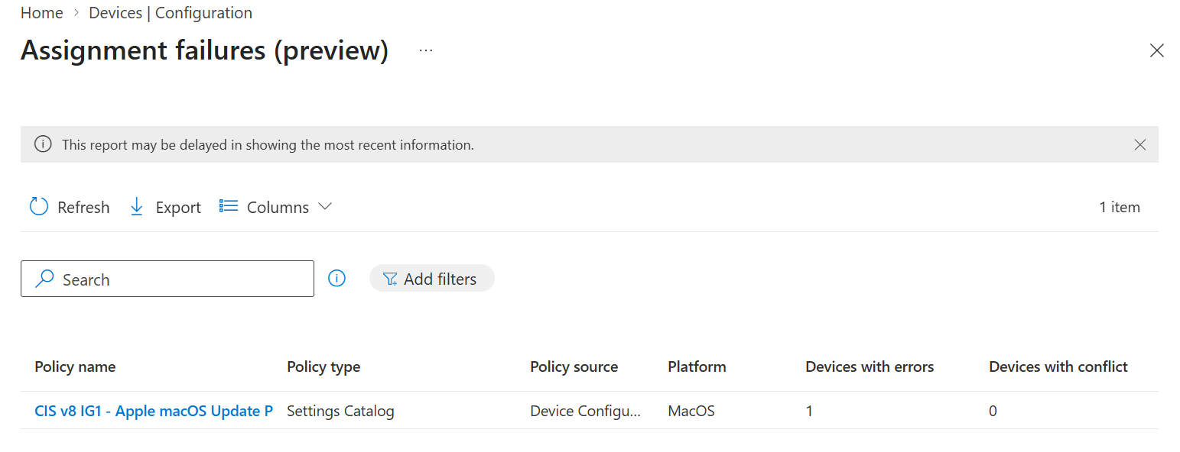
Figure 5. Assignment failures report. The report lists policies that have one or more failed assignments and helps prioritize operational investigation.
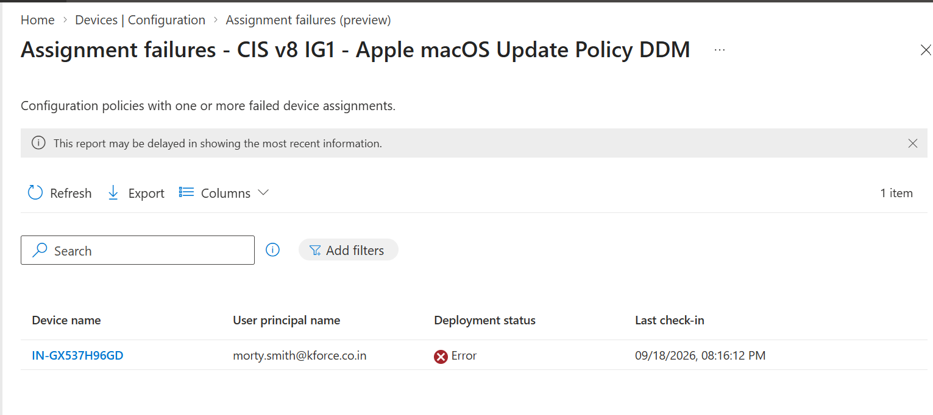
Figure 6. Assignment failure detail for an Apple macOS update policy, showing the failed policy record.

6.1 How to investigate assignment failure
- Open Assignment failures.
- Filter by policy, platform, user, or device.
- Open the failed policy.
- Confirm the assignment group and effective membership.
- Confirm platform and OS support.
- Check whether the setting is device-scoped or user-scoped.
- Review per-setting status.
- Verify network and device check-in.
- Collect client logs and local state.
- Document root cause and resolution.

6.2 Failure flowchart
Failure report | → | Confirm target | → | Check applicability | → | Review setting status | → | Collect logs | → | Remediate | → | Re-sync

6.3 Common causes
Cause | Example | Resolution
Wrong scope | User setting assigned only to device without user session | Use correct user/device group
Unsupported OS/edition | CSP not supported on installed edition | Adjust requirement or use supported scope
Conflict | Two profiles configure different values | Consolidate ownership and remove overlap
Data/config error | Invalid OMA-URI or value | Correct path/data type/value
Dependency | Certificate or ADMX dependency missing | Deploy dependency first
Stale device | Device has not checked in | Restore connectivity and sync

7. Devices with Restricted Apps
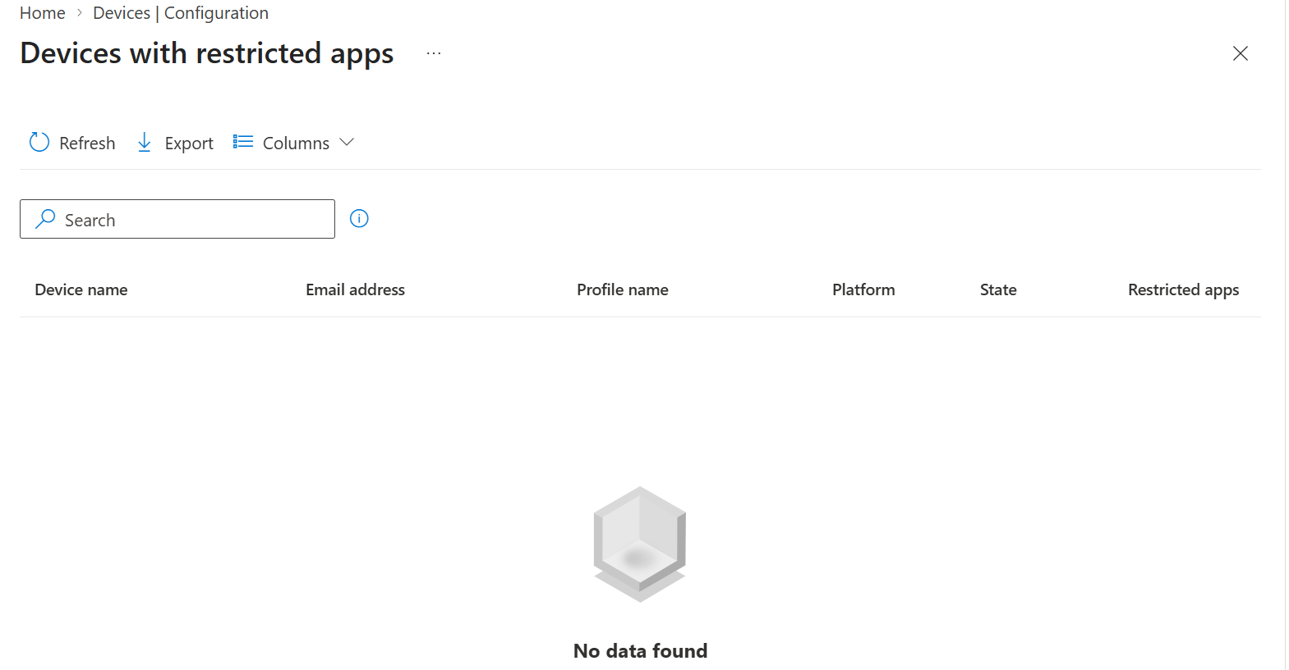
Figure 7. Devices with restricted apps report, showing device and user identifiers.

7.1 What the report means
This report identifies devices where an application restriction policy detected restricted applications. It is useful for validating allowed/blocked application governance, but it does not replace application inventory, Defender discovery, or software asset management.

7.2 Investigation procedure
- Open the report.
- Export results for audit evidence.
- Confirm the source configuration profile and restriction definition.
- Identify device, user, application, detection time, and ownership.
- Validate whether the application is truly prohibited or falsely matched.
- Coordinate remediation with user, manager, security, and software governance.
- Remove or allow the application through approved change.
- Re-sync and confirm the report clears.

7.3 Real-world example
Scenario
A prohibited remote-access utility appears on a corporate laptop. The endpoint engineer confirms the device and user, validates the exact app, opens a security ticket, removes the app, blocks reinstallation using the organization’s approved security control, and records the evidence.

8. Encryption Report and BitLocker Architecture
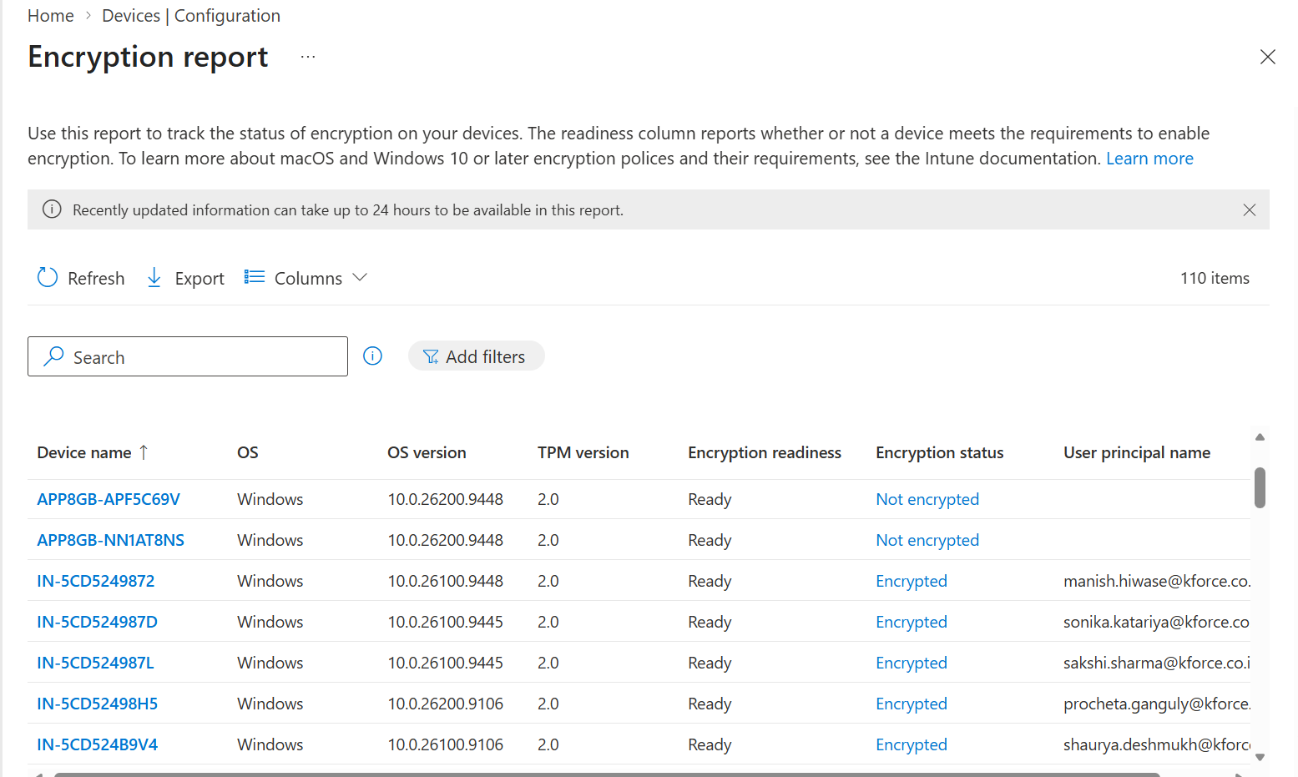
Figure 8. Encryption report showing encryption status and readiness across devices.
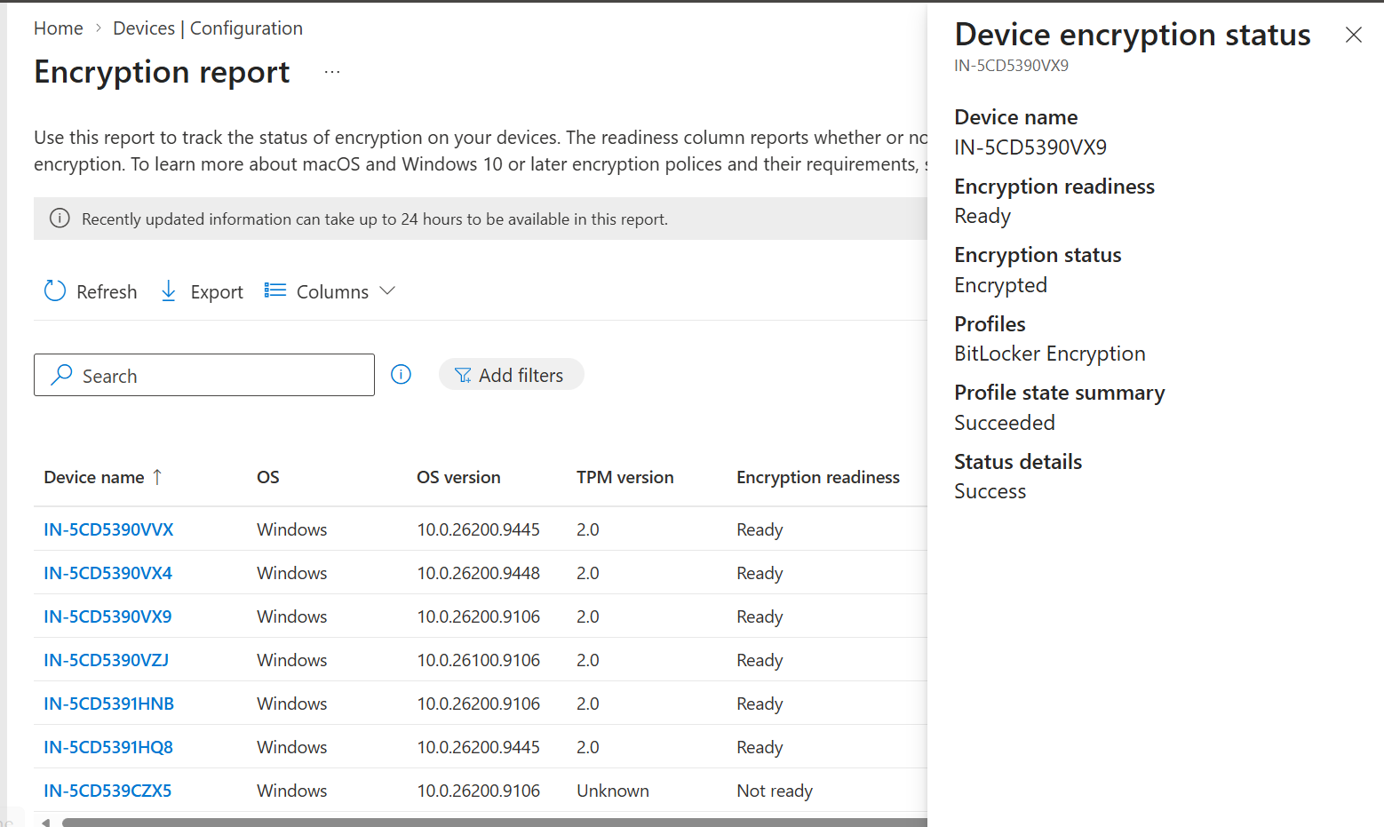
Figure 9. Encryption report continuation with readiness, TPM, and device details.

8.1 What the report provides
- Encryption status.
- Readiness to enable encryption.
- Platform and OS context.
- TPM-related information where reported.
- Operational visibility across Windows and macOS encryption policies.

8.2 Configuration vs report
Disk encryption policy | → | Device receives settings | → | BitLocker/FileVault enables | → | Key escrow occurs | → | Encryption report updates | → | Compliance validates

8.3 Real-world example
Scenario
A device reports Ready but Not encrypted. The engineer checks the Endpoint security disk-encryption profile assignment, per-setting status, TPM state, edition, reboot requirements, and recovery-key escrow. The engineer does not treat readiness as proof of encryption.

8.4 Troubleshooting
- Check encryption policy assignment.
- Check TPM state and BIOS.
- Check local encryption status.
- Check recovery key in Intune/Entra.
- Review per-setting conflicts.
- Review last check-in and report latency notice.
- Validate device ownership and user context.

9. Certificate Inventory and Lifecycle
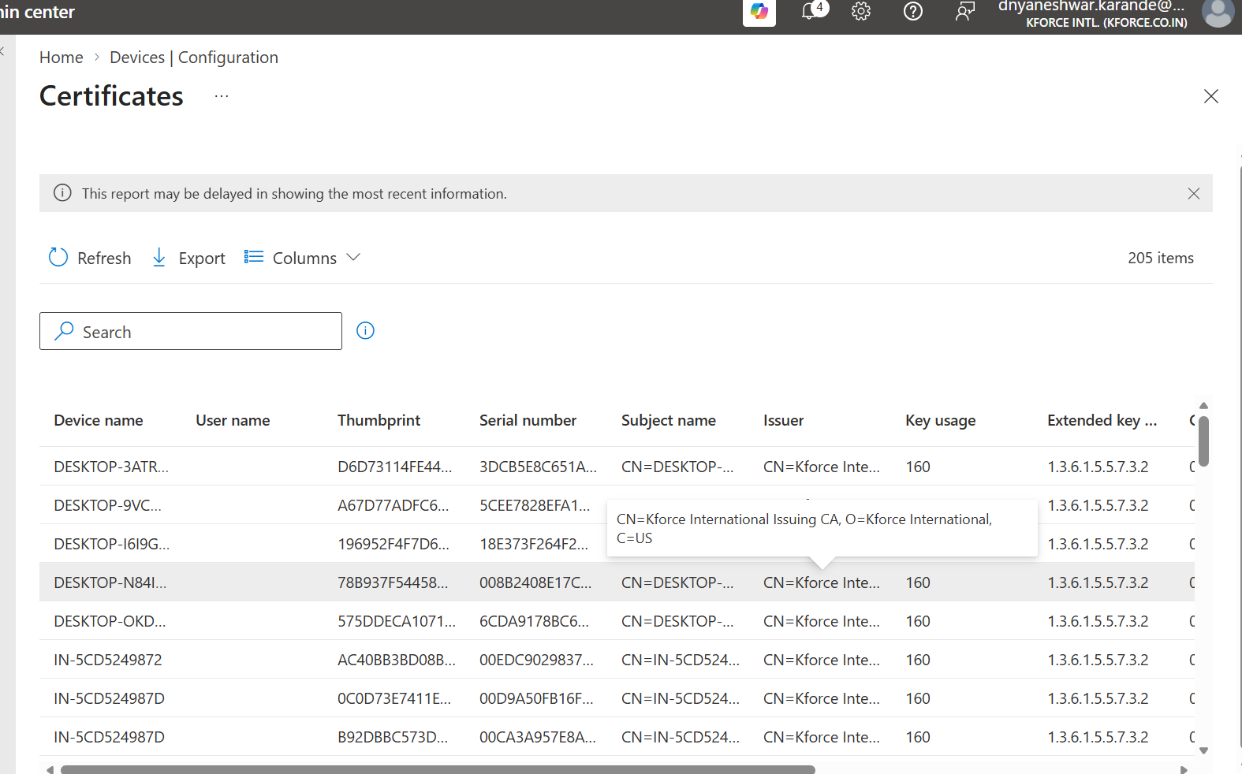
Figure 10. Certificates report with certificate inventory, device, user, and issuance details.
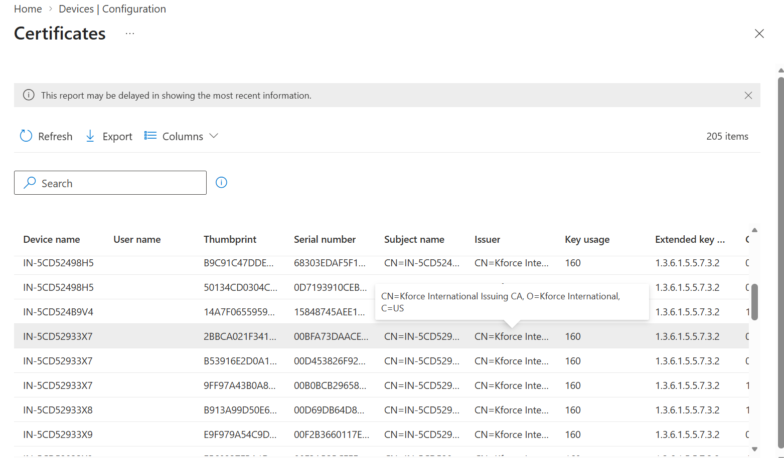
Figure 11. Certificates report with additional records and expiration information.
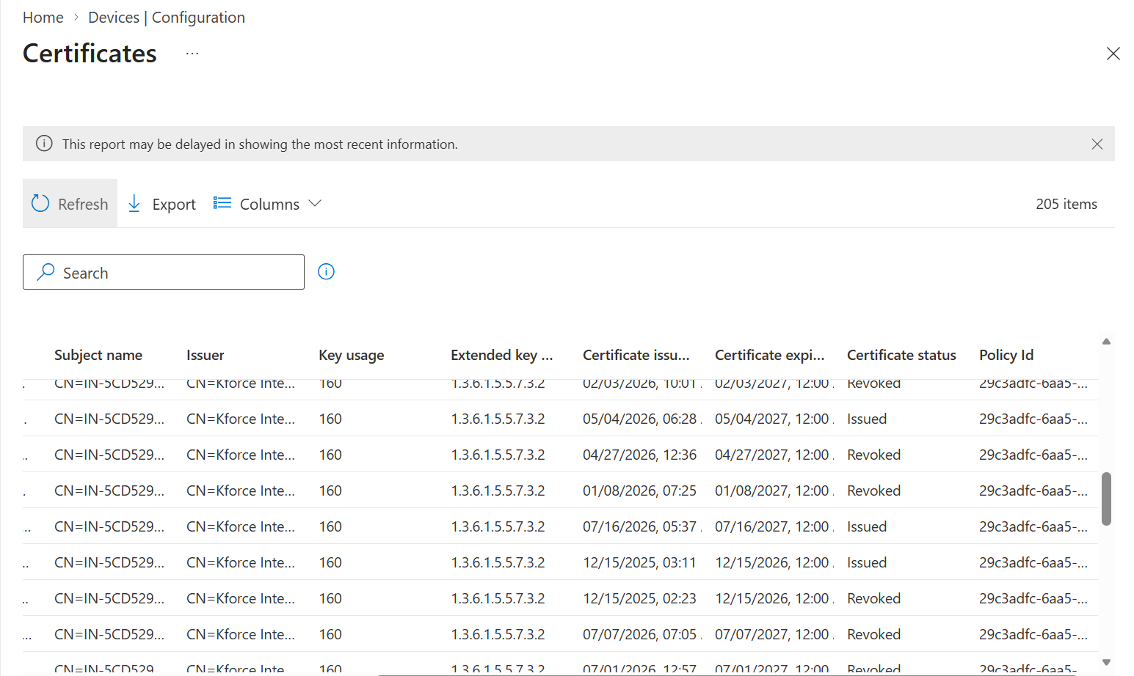
Figure 12. Certificate report filtered or continued for operational review.

9.1 Why certificate visibility matters
Certificates support Wi-Fi, VPN, S/MIME, authentication, and device trust. Expired, missing, duplicated, or mis-scoped certificates can break access even when a configuration profile reports success.

9.2 Certificate architecture
Trusted root profile | → | SCEP/PKCS profile | → | Certificate connector/CA | → | Device receives cert | → | Wi-Fi/VPN uses cert | → | Report/renewal

9.3 Real-world example
Scenario
Corporate Wi-Fi fails after a certificate renewal. The engineer checks the trusted root chain, SCEP profile assignment, connector health, certificate subject/SAN, expiry, user/device scope, and Wi-Fi EAP configuration.

9.4 Operational checks
- Export certificate inventory.
- Track expiry before outage.
- Confirm chain and issuing CA.
- Confirm certificate is user or device scoped as intended.
- Confirm connectors and NDES/PKCS services when used.
- Test renewal and replacement.
- Remove obsolete certificates carefully.

10. Browser Settings Profile: Overview and Assignment
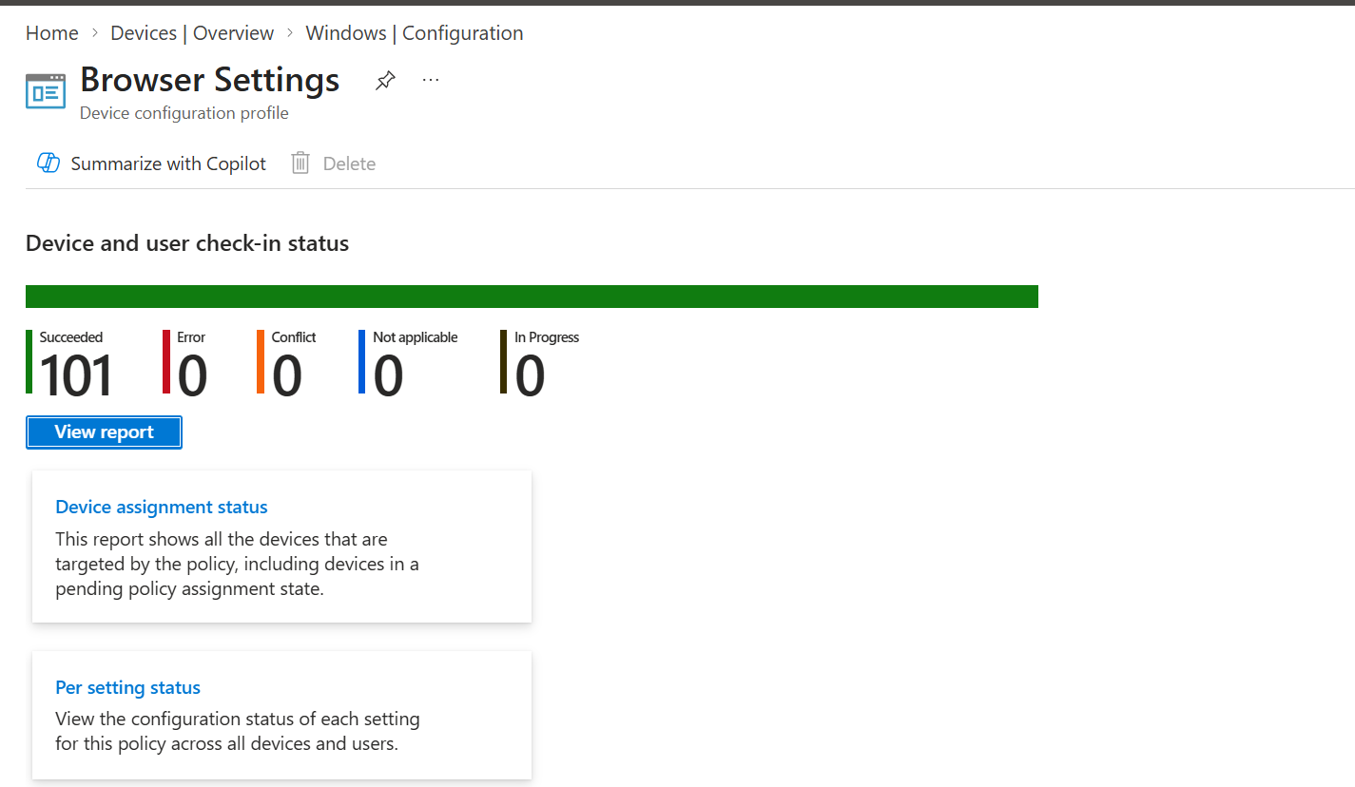
Figure 13. Browser Settings profile overview with device and user check-in status.
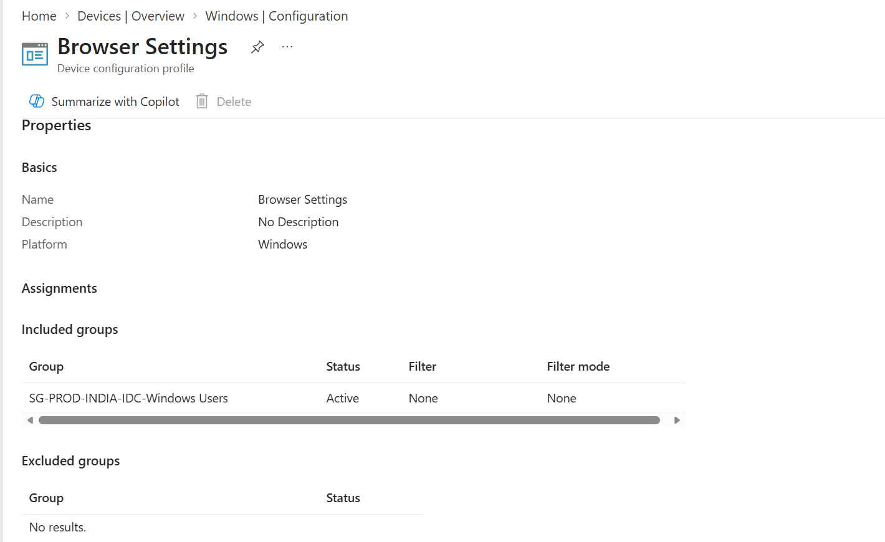
Figure 14. Browser Settings properties, profile type, configuration settings, and assignments.

10.1 What this profile demonstrates
A single Settings Catalog profile can configure Google Chrome and Microsoft Edge settings. This can simplify browser governance, but combining many products in one profile increases blast radius. Separate profiles may be better when Chrome and Edge have different owners or release cycles.

10.2 Assignment decisions
Question | Design choice
Device or user settings? | Assign according to the scope shown in the setting name. Settings marked User apply in user context.
One profile or separate? | Separate by product or risk when ownership and rollback differ.
Pilot scope? | Use a small IT/browser pilot group before broad deployment.
Conflicts? | Check imported ADMX, Settings Catalog, GPO, and browser cloud management.

10.3 Validation
- Open profile status.
- Confirm target devices/users received the profile.
- Open browser policy page such as edge://policy or chrome://policy on a test device.
- Confirm source, level, value, and status.
- Test the user experience.

11. Google Chrome and Microsoft Edge Settings Deep Dive
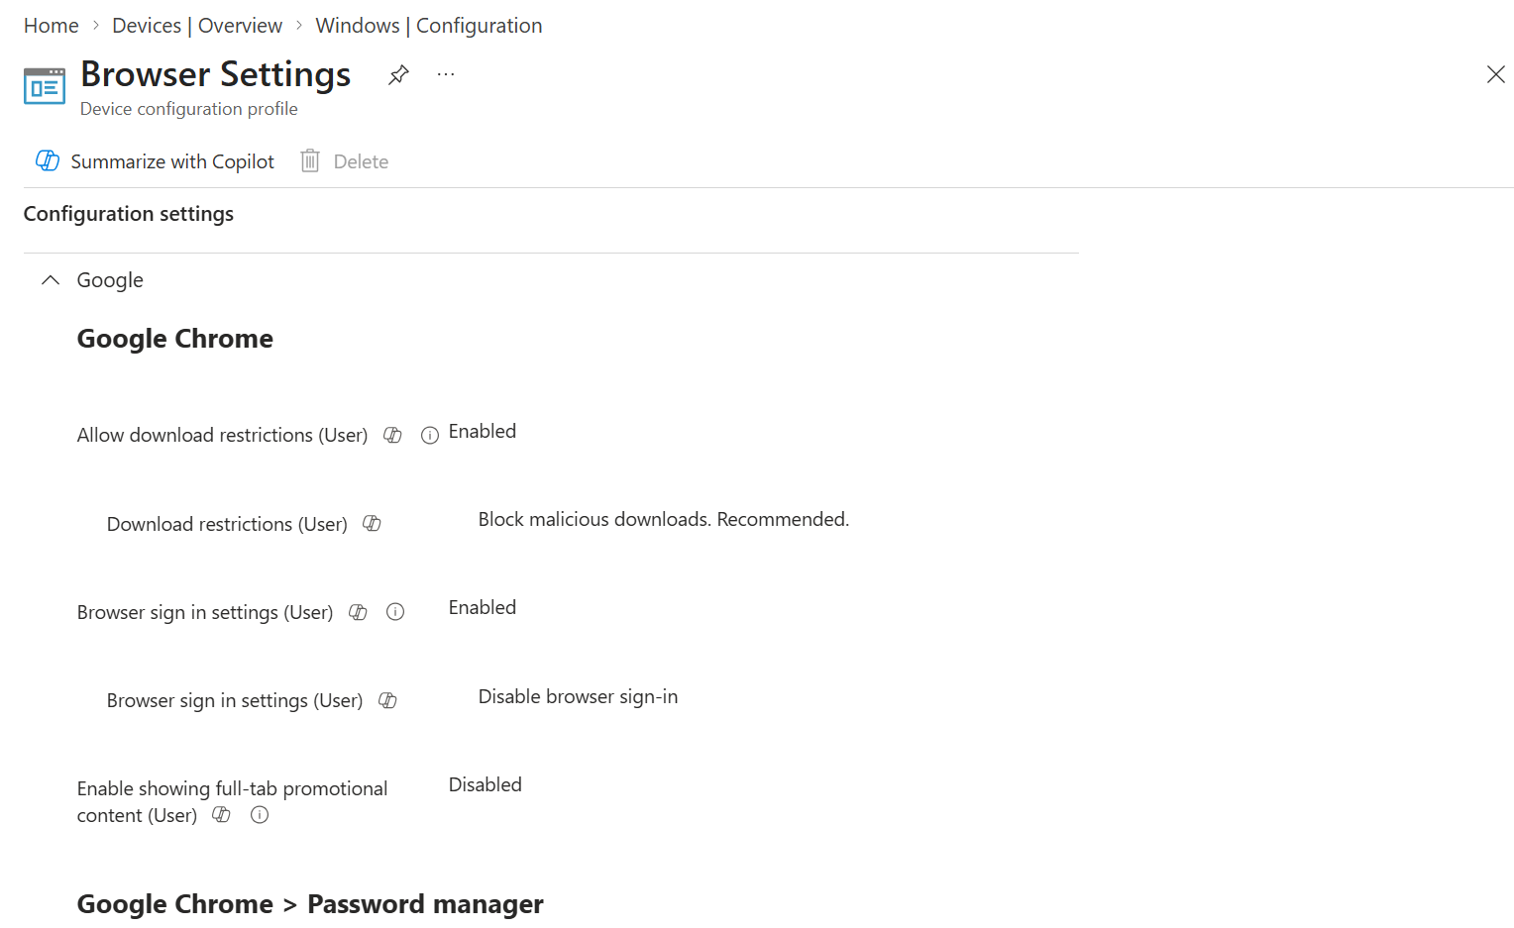
Figure 15. Browser Settings configuration for Google Chrome sign-in, password manager, and related categories.
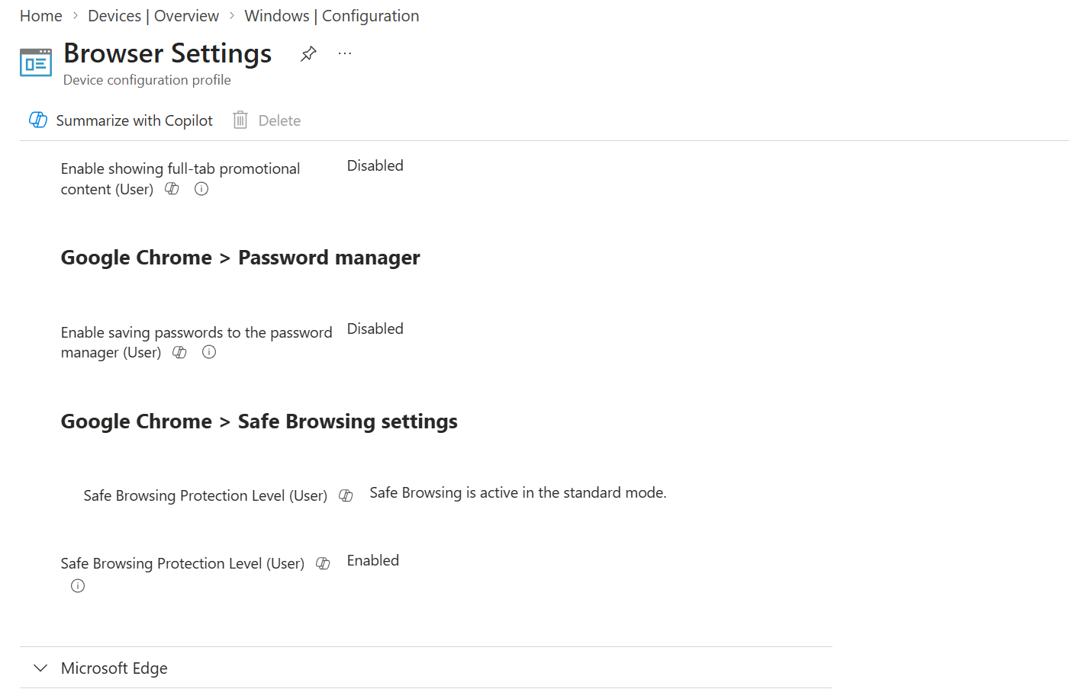
Figure 16. Chrome password manager and Safe Browsing settings plus Microsoft Edge categories.
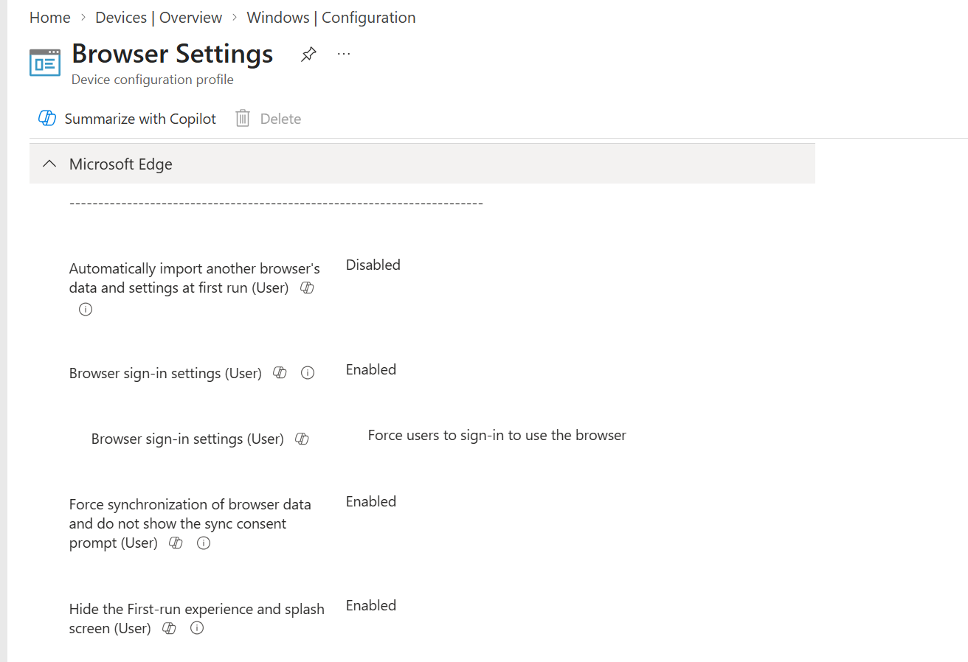
Figure 17. Microsoft Edge browser sign-in settings.
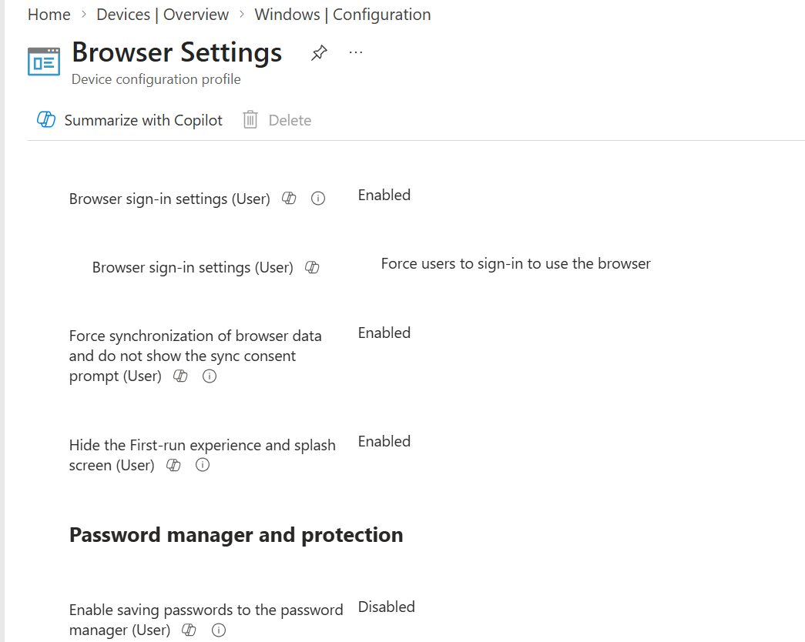
Figure 18. Browser sign-in policy configured to require sign-in.

11.1 Browser sign-in
Choice | Effect | Use case
Disable sign-in | Prevents browser profile sign-in | Shared or restricted devices
Enable sign-in | Allows user choice | Standard managed browser
Force sign-in | Requires organizational browser sign-in | Managed sync and identity-aligned browsing

11.2 Password manager
- Decide whether the built-in password manager is permitted.
- Coordinate with enterprise password manager policy.
- Avoid conflicting Chrome, Edge, and third-party browser controls.
- Explain user impact before disabling stored passwords.

11.3 Safe Browsing and security
- Use vendor-supported security controls.
- Coordinate browser baseline, SmartScreen/Safe Browsing, download restrictions, and Defender web protection.
- Pilot to avoid blocking required business sites or downloads.

11.4 Real-world example
Scenario
The organization requires Edge sign-in and disables consumer profile usage while allowing Chrome only for a legacy application. Separate profiles are used: Edge Corporate Standard and Chrome Legacy Restricted. Each has different assignments and rollback.

12. Browser Extension Governance
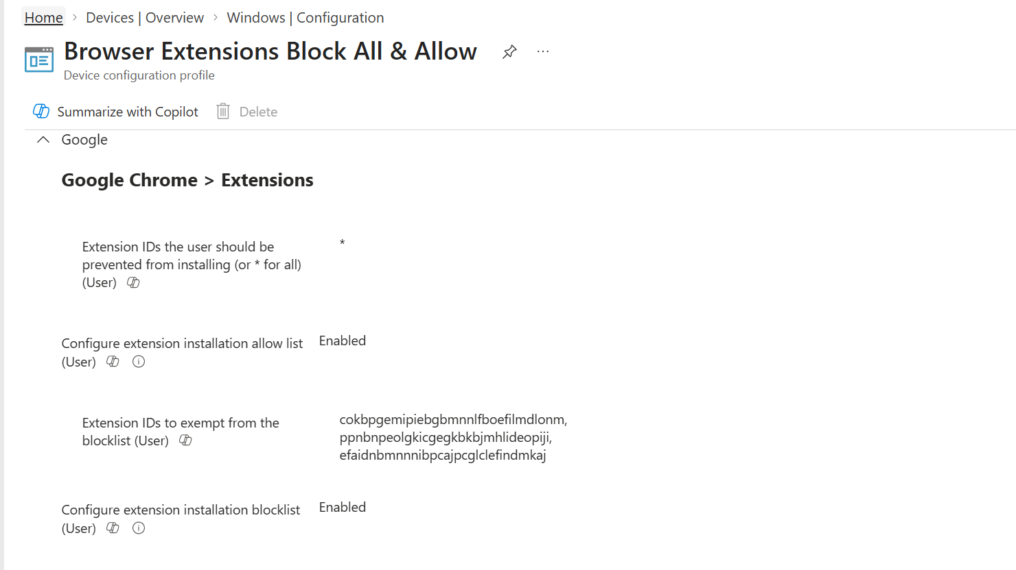
Figure 19. Chrome extension policy using block-all and allow-list controls.
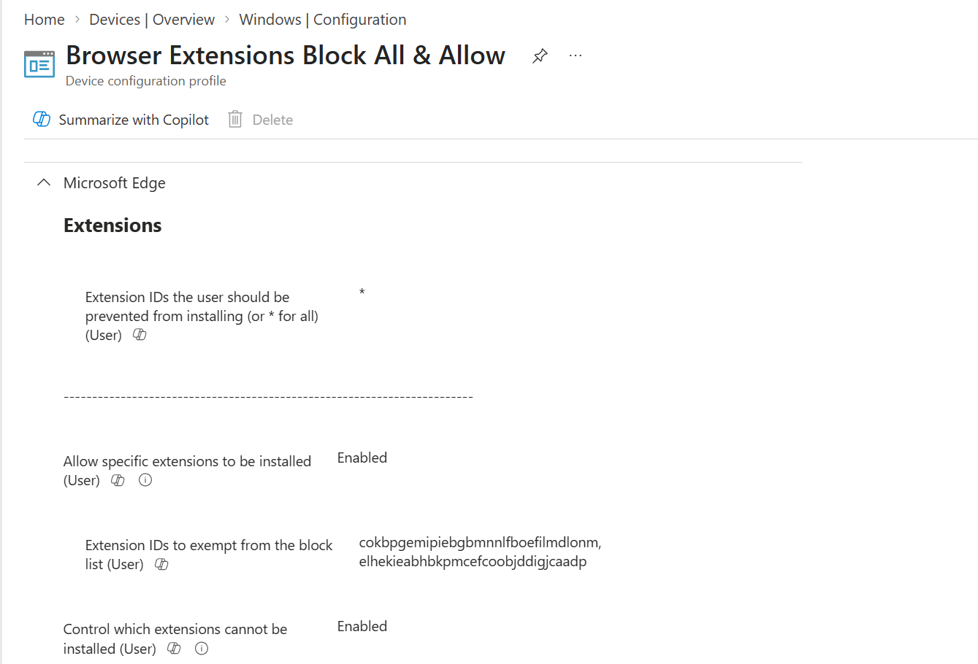
Figure 20. Microsoft Edge extension controls.

12.1 Extension control model
Control | Purpose
Block list | Prevents listed extensions; wildcard can block all by default
Allow list | Permits approved extensions when a broad block exists
Force install | Installs required security or business extension
External extensions | Controls potentially unmanaged extension sources

12.2 Secure design flow
Inventory extensions | → | Assess risk | → | Approve IDs | → | Block by default | → | Allow/force required | → | Monitor impact

12.3 Common errors
- Using extension display name instead of extension ID.
- Blocking all without allow-listing security and business extensions.
- Force-installing an extension unavailable in the selected store.
- Combining Chrome ADMX, Settings Catalog, and browser-cloud policy without ownership.

12.4 Real-world example
Scenario
A data-loss-prevention browser extension must be force-installed. The engineer pilots the extension, confirms the store URL and ID, adds the extension to allow and force-install policies, validates chrome://policy and edge://policy, and confirms there is no browsing performance impact.

13. OneDrive Custom Configuration Profile
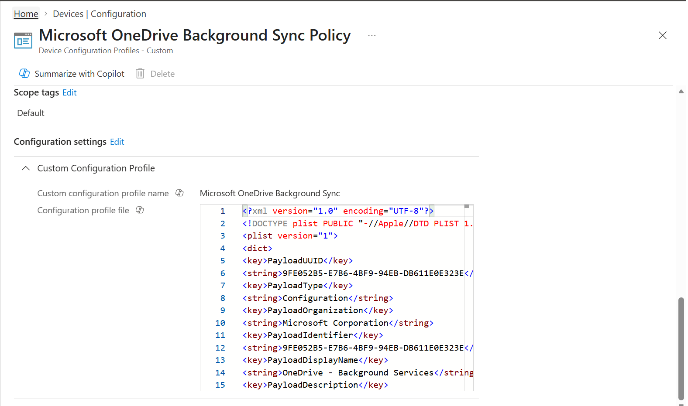
Figure 21. Microsoft OneDrive Background Sync Policy using a Custom configuration profile and uploaded configuration content.

13.1 What the screenshot shows
The profile uses a Custom configuration payload rather than ordinary Settings Catalog fields. Custom profiles can deliver platform-specific configuration content, but require exact format, schema, identifiers, and vendor documentation.

13.2 Preferred design order
Search Settings Catalog | → | Check OneDrive ADMX | → | Check vendor-supported profile | → | Use Custom only if necessary

13.3 OneDrive management areas
- Silent account configuration.
- Known Folder Move.
- Files On-Demand.
- Sync restrictions and tenant allow-list.
- Background service behavior.
- Update ring and sync health.

13.4 Validation procedure
- Confirm the package/file format and schema.
- Assign to a pilot group.
- Sync the device.
- Review Intune status.
- Confirm OneDrive process and sign-in.
- Verify policy in registry or application diagnostics according to vendor documentation.
- Test background sync, file hydration, and Known Folder Move.

13.5 Real-world example
Scenario
A remote user signs in to Windows through Autopilot. OneDrive silently signs in, Known Folder Move redirects Desktop/Documents/Pictures, and Files On-Demand limits initial bandwidth. The engineer validates tenant ID, sync state, and user communication.

14. Wireless Profile Architecture and Reporting
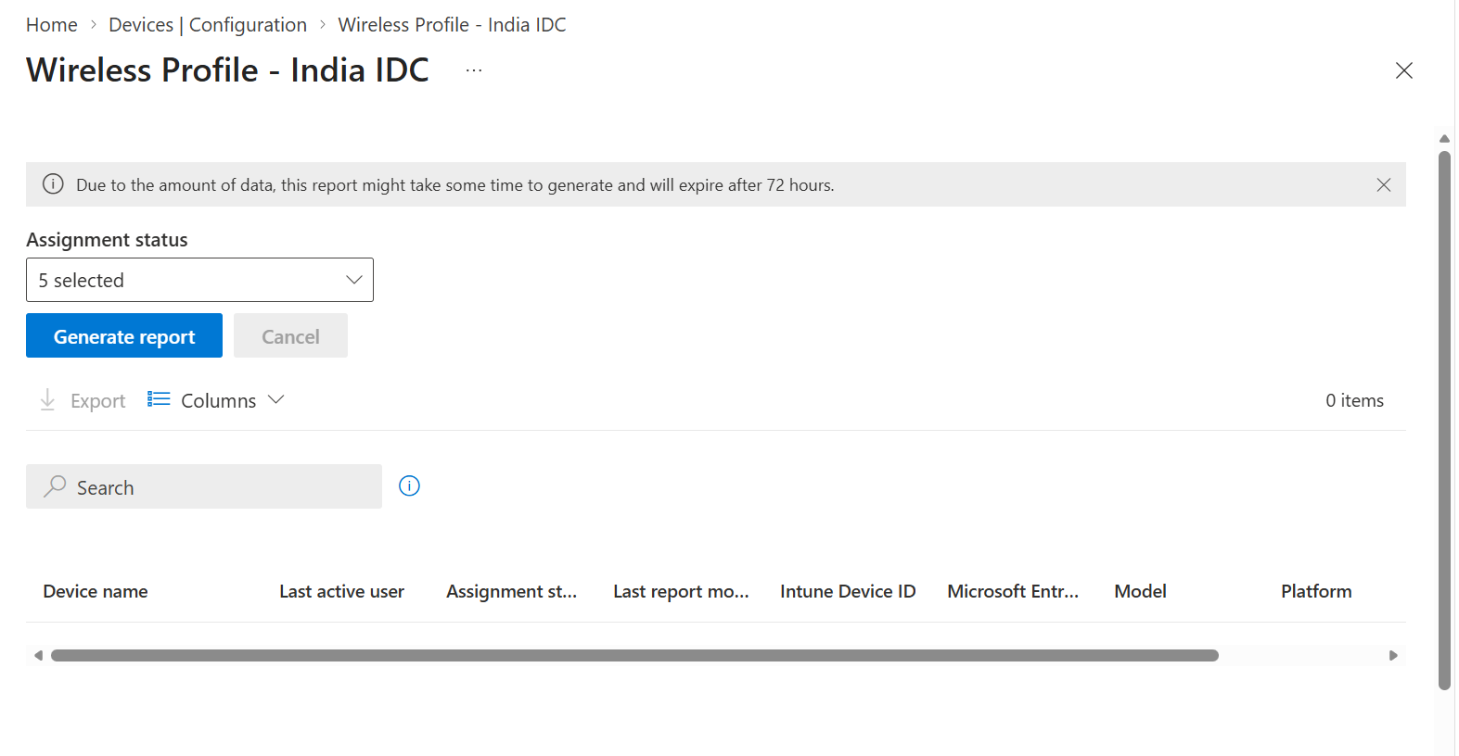
Figure 22. Wireless Profile - India IDC assignment status report.
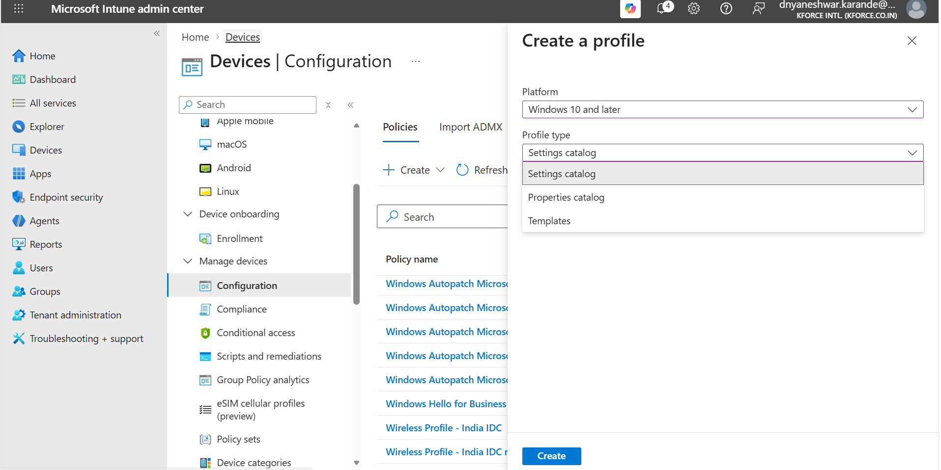
Figure 23. Wireless Profile properties with Settings Catalog, Templates, and assignment context.

14.1 Create Wi-Fi profile
Exact portal path
Microsoft Intune admin center > Devices > Configuration > Create > New policy > Windows 10 and later > Templates > Wi-Fi

- Choose Basic or Enterprise Wi-Fi based on authentication.
- Enter SSID exactly.
- Configure hidden network and auto-connect behavior.
- For Enterprise Wi-Fi, configure EAP type and certificate authentication.
- Deploy trusted root and SCEP/PKCS certificates first.
- Assign to a pilot device/user group according to certificate scope.
- Validate on corporate network.

14.2 Wi-Fi dependency flow
Root certificate | → | Client certificate | → | Wi-Fi profile | → | Device connects | → | RADIUS validates | → | Report confirms

14.3 Real-world failure
Scenario
The Wi-Fi profile succeeds in Intune but the device cannot connect. Investigation shows the device certificate is missing because SCEP assignment was user-scoped. The architect aligns certificate and Wi-Fi scope, reissues the certificate, and validates RADIUS logs.

15. Custom OMA-URI and CSP Deep Dive

15.1 When Custom is justified
- The setting is explicitly documented in a Microsoft CSP.
- No Settings Catalog or template setting provides the same requirement.
- The target Windows edition and version support the CSP.
- The OMA-URI path, scope, data type, and allowed value are known.
- A rollback method is documented.

15.2 Create Custom profile
Exact portal path
Microsoft Intune admin center > Devices > Configuration > Create > New policy > Windows 10 and later > Templates > Custom

- Enter Name and Description.
- Select Add for a custom setting.
- Enter a clear setting name and description.
- Enter the exact OMA-URI path.
- Select the documented data type.
- Enter or upload the value exactly as required.
- Add scope tags and pilot assignments.
- Review and create.

15.3 Data types
Type | Example use
Boolean | Enable/disable a CSP setting
Integer | Numeric limit or enum value
String | Text value, path, identifier
String XML | XML payload for a CSP setting
Base64/File | Payload where explicitly documented

15.4 Troubleshooting
- Check OMA-URI spelling and ./Vendor/MSFT prefix.
- Check user vs device scope.
- Check data type and XML escaping.
- Check edition/build support.
- Review MDM diagnostic report and event logs.
- Set a rollback value or remove assignment after validation.

16. Administrative Templates Migration Strategy

16.1 Why migrate
Microsoft documents the older Administrative Templates profile type as deprecated and read-only. Existing profiles need inventory and controlled migration into Settings Catalog, not blind recreation.

16.2 Migration flow
Export legacy settings | → | Map to catalog | → | Create replacement | → | Pilot side-by-side carefully | → | Remove overlap | → | Expand rollout | → | Retire legacy

16.3 Validation matrix
Check | Evidence
Setting scope | User or device matches legacy behavior
Registry/CSP effect | Same effective value
Assignment | Same included/excluded users/devices
Filters | Equivalent filtering
Reporting | No errors/conflicts
Rollback | Legacy profile can be restored if needed

16.4 Common migration mistake
Mistake
Assigning the new Settings Catalog policy while the legacy profile still configures the same setting can create duplicate sources or conflicts. Plan a staged swap and verify effective behavior.

17. Profile Monitoring and Status Interpretation

17.1 Profile path
Exact portal path
Microsoft Intune admin center > Devices > Configuration > Policies > select profile > Monitor

Report | Purpose
Device and user check-in status | Overall state by device/user
Device assignment status | Assignment-level status
Per-setting status | Exact setting error/conflict
Assignment failures | Policies with failed assignments
Encryption report | Readiness and encryption status
Certificates | Certificate inventory and expiry
Restricted apps | Restricted application detections

17.2 Status interpretation
Status | Meaning | Action
Succeeded | Intune reports success | Validate actual device behavior
Error | Setting processing failure | Open per-setting status and collect logs
Conflict | Competing policy settings | Find all policy sources
Not applicable | Unsupported platform/edition/context | Validate requirements and scope
Pending | Awaiting check-in or processing | Check last sync and network

17.3 Sync paths
- Windows Settings > Accounts > Access work or school > connected work account > Info > Sync.
- Company Portal > Settings > Sync.
- Intune admin center > Devices > Windows > select device > Sync.

18. Client-Side Troubleshooting

18.1 Commands
dsregcmd /status
gpresult /h C:\Temp\gpresult.html
mdmdiagnosticstool.exe -area DeviceProvisioning -cab C:\Temp\MDMDiag.cab
certutil -store My
manage-bde -status

18.2 Event Viewer
- Applications and Services Logs > Microsoft > Windows > DeviceManagement-Enterprise-Diagnostics-Provider > Admin.
- Applications and Services Logs > Microsoft > Windows > User Device Registration > Admin.
- Applications and Services Logs > Microsoft > Windows > AAD > Operational where available.

18.3 Browser validation
edge://policy
chrome://policy
edge://management
chrome://management

18.4 Policy troubleshooting order
Targeting | → | Applicability | → | Conflict | → | Device check-in | → | Client processing | → | Local state | → | Report

19. Real-World Configuration Profile Catalog
Profile | Recommended type | Core settings
Browser Corporate Standard | Settings Catalog | Sign-in, sync, password manager, Safe Browsing
Browser Extensions | Settings Catalog/ADMX | Block, allow, force-install
OneDrive Corporate | Settings Catalog/ADMX | Silent sign-in, KFM, Files On-Demand
Corporate Wi-Fi | Wi-Fi template | SSID, EAP, certificates
VPN | VPN template | Connection, authentication, routes
Certificate Roots | Trusted certificate template | Root/intermediate trust
Certificate Enrollment | SCEP/PKCS template | Client authentication cert
Device Restrictions | Settings Catalog | OS/user restrictions
Windows Hello | Account protection / Settings Catalog | PIN, biometric, trust model
Custom CSP | Custom template | Only documented unsupported-in-catalog CSP

19.1 Separation principle
- Separate different owners.
- Separate high-risk changes.
- Separate device and user scope when practical.
- Separate browser product policies.
- Keep profile size manageable.
- Avoid one giant all-settings profile.

20. Architecture Patterns for Enterprise Scale

20.1 Multi-country design
- Global baseline profiles for common settings.
- Regional overlays only for genuine regional differences.
- Scope tags for delegated administration.
- Assignment filters for supported device attributes.
- Central naming and change control.

20.2 Pilot and production rings
Ring | Purpose
Lab | Validate syntax and local behavior
IT pilot | Validate supportability and reporting
Business pilot | Validate applications, network, and user experience
Production wave | Controlled rollout by region/department
Broad | Standard estate after exit criteria

20.3 Conflict prevention
- One authoritative owner per setting family.
- Policy catalog documenting where each setting is configured.
- Avoid duplicate Settings Catalog, baseline, GPO, and Custom settings.
- Use per-setting reporting before adding another policy.
- Retire old profiles after migration.

21. Governance, Naming, and Change Control

21.1 Naming examples
WIN-SC-Edge-Corporate-v1
WIN-SC-Chrome-Restricted-v1
WIN-TPL-WiFi-India-IDC-v1
WIN-SC-OneDrive-KFM-v1
WIN-CUSTOM-<CSP-Purpose>-v1

21.2 Policy naming convention template
Standard pattern
<Platform>-<ProfileType>-<Workload>-<ScopeOrRegion>-<Environment>-v<Major>.<Minor>

Token | Allowed examples | Purpose
Platform | WIN, MAC, IOS, AND, LNX | Identifies the managed operating system
ProfileType | SC, TPL, ADMX, CUSTOM, SEC | Settings Catalog, Template, imported ADMX, Custom, or security profile
Workload | Edge, Chrome, OneDrive, WiFi, VPN, Cert, Restrictions | Describes the primary managed workload
ScopeOrRegion | Global, India, Pune, Sales, Kiosk | Identifies genuine scope or regional variation
Environment | LAB, PILOT, PROD | Identifies rollout stage when parallel objects are required
Version | v1.0, v1.1, v2.0 | Tracks controlled revisions

21.3 Naming rules
- Use short, stable tokens documented in the policy catalog.
- Do not place user names, ticket numbers, dates, or temporary project names in the permanent policy name.
- Use Description for owner, requirement, ticket, review date, assignments, dependencies, and rollback.
- Use a major version for architecture or behavior changes and a minor version for controlled setting adjustments.
- Avoid cloning with names such as Copy, New, Final, Final2, or Test unless the object is a short-lived laboratory policy.
- Retire and archive superseded names after the replacement is validated.

21.4 Ready-to-copy templates
WIN-SC-<Workload>-<Scope>-<Environment>-v1.0
WIN-TPL-<Workload>-<Scope>-<Environment>-v1.0
WIN-ADMX-<VendorOrWorkload>-<Scope>-<Environment>-v1.0
WIN-CUSTOM-<CSPPurpose>-<Scope>-<Environment>-v1.0
MAC-SC-<Workload>-<Scope>-<Environment>-v1.0

Example
WIN-SC-Edge-Global-PROD-v2.0 = Windows Settings Catalog profile for the global Microsoft Edge production standard, major architecture version 2.

21.5 Required documentation
- Business and technical owner.
- Requirement and source documentation.
- Platform/edition/version support.
- Profile type and settings.
- Groups, exclusions, filters, and scope tags.
- Pilot evidence.
- User impact and communication.
- Rollback.
- Support and monitoring path.
- Change ticket and approval.

21.6 Change flow
Requirement | → | Design review | → | Lab test | → | Pilot | → | Approval | → | Production waves | → | Monitor | → | Retire/replace

22. Troubleshooting Matrix
Symptom | Likely cause | Action
Policy not received | Assignment or sync issue | Confirm group/filter and force sync
Not applicable | Unsupported edition/build/scope | Review setting support and user/device context
Conflict | Multiple profiles/GPO/baseline | Use per-setting status and policy inventory
Custom OMA-URI error | Wrong path/type/value | Validate CSP documentation and event log
Browser policy missing | Wrong scope or competing browser management | Check browser policy page and source
OneDrive not silent | Tenant ID/user sign-in/profile conflict | Review OneDrive policy and client logs
Wi-Fi fails | Certificate/EAP/RADIUS dependency | Validate cert chain, scope, and RADIUS logs
Certificate missing | Connector/template/assignment issue | Review connector and profile status
Encryption report mismatch | Report delay or policy/key issue | Check local BitLocker and key escrow
Assignment failure | Unsupported target or invalid payload | Open detailed failure and client logs

23. Interview and Expert Reference
Question | Strong answer
Settings Catalog vs Templates? | Settings Catalog is the unified searchable platform; templates are purpose-built experiences for specific workloads.
What is OMA-URI? | The path used by MDM to configure a CSP setting; it requires exact path, type, and value.
What is ADMX-backed policy? | A policy based on Administrative Template definitions, typically mapping to registry-backed application/Windows settings.
Why avoid giant profiles? | They increase blast radius, ownership ambiguity, and troubleshooting complexity.
Succeeded but behavior wrong? | Validate local effective state, scope, conflicts, and application-specific policy pages.
User vs device setting? | User settings apply in signed-in user context; device settings apply to the device.
How do you troubleshoot conflicts? | Use per-setting status, inventory every policy source, GPO, baseline, and custom CSP.
How do certificates affect Wi-Fi? | Enterprise Wi-Fi often depends on trusted roots and user/device authentication certificates.
Why migrate Admin Templates? | The legacy profile type is deprecated/read-only; new ADMX policies should use Settings Catalog.
What is scope tag? | An RBAC visibility/delegation control, not a deployment assignment.

24. Reusable Design and Incident Records

24.1 Profile design record
Field | Record
Profile name/version
Owner
Requirement
Profile type
Settings/source
Platform support
Groups/filters
Scope tags
Pilot evidence
User impact
Rollback
Ticket/approval

24.2 Incident record
Field | Record
Device/user
Profile/setting
Status/error
Assignment
Local evidence
Root cause
Remediation
Validation
Owner/date

25. Advanced Assignment Filters and Scope Tags

25.1 Assignment filters
Assignment filters refine an included group at deployment time. Filters do not replace Microsoft Entra group design. Use filters for stable device attributes when creating a separate group would add unnecessary operational overhead.

25.2 Safe filter workflow
Define attribute | → | Create filter | → | Test syntax | → | Assign include/exclude | → | Pilot | → | Validate effective targets

25.3 Scope tags
Scope tags control which Intune administrators can see and manage objects. Scope tags do not deploy a policy to devices. Combine scope tags with RBAC role assignments and administrative groups.

25.4 Real-world example
Scenario
The Pune service desk can view and manage India Wi-Fi and certificate profiles but cannot edit global browser security. Scope tags and RBAC provide administrative separation, while Entra groups provide deployment targeting.

26. VPN Profile Architecture
Exact portal path
Microsoft Intune admin center > Devices > Configuration > Create > New policy > Windows 10 and later > Templates > VPN

26.1 Design inputs
- VPN type and vendor.
- Server and DNS endpoints.
- User or device tunnel.
- Authentication based on certificate, user credentials, or modern authentication.
- Split or force tunneling.
- Always On and trusted-network detection.
- Proxy and route requirements.

26.2 Dependency flow
Root trust | → | Client certificate | → | VPN profile | → | Authentication | → | Tunnel | → | Application access

26.3 Real-world example
Scenario
A remote Autopilot device needs VPN before accessing a legacy application. The architect deploys trusted roots, a device certificate, and a device tunnel profile, then validates pre-logon connectivity and conditional-access exclusions.

27. Trusted Certificate, SCEP, and PKCS Profiles

27.1 Trusted root profile
Trusted certificate profiles deliver root or intermediate certificates. A trusted root profile does not issue a client certificate.

27.2 SCEP and PKCS
Method | Typical use | Dependency
SCEP | Scalable certificate enrollment via NDES/SCEP | Certificate connector, NDES, CA template
PKCS | Certificate issuance through Intune Certificate Connector | CA and connector
Imported PFX | Specific supported certificate scenarios | Secure PFX handling

27.3 Validation
certutil -store Root
certutil -store My

27.4 Real-world example
Scenario
A certificate appears under Trusted Root but Wi-Fi still fails because no client certificate exists in Personal. The engineer distinguishes trust delivery from identity certificate enrollment and fixes the SCEP assignment.

28. Device Restrictions Architecture

28.1 Common control areas
- Windows experience and consumer features.
- Control Panel and Settings access.
- Camera, Bluetooth, removable storage, and screen capture.
- Microsoft Store and application controls.
- Cloud content, search, and telemetry options.

28.2 Design caution
Restrictions can affect productivity and support. Group settings by business outcome, document user impact, and avoid mixing low-risk cosmetic settings with high-impact device restrictions.

28.3 Rollout
Requirement | → | Security review | → | Lab | → | User-impact test | → | Pilot | → | Communication | → | Production

29. Windows Hello for Business and Account Protection

29.1 Architecture choices
- Cloud Kerberos trust, key trust, or certificate trust where applicable.
- PIN complexity and biometric availability.
- User registration experience.
- Break-glass and recovery procedures.
- Interaction with Conditional Access and passwordless strategy.

29.2 Profile placement
Use the dedicated Account protection workload or supported Settings Catalog settings according to the tenant design. Avoid configuring the same Windows Hello behavior through multiple policy surfaces.

29.3 Real-world example
Scenario
Autopilot users are prompted for Windows Hello registration. A pilot validates PIN reset, biometrics, Cloud Kerberos access, and help-desk recovery before broad rollout.

30. Shared, Kiosk, and Multi-User Device Profiles

30.1 Design differences
Device type | Configuration focus
Shared laptop | Shared PC policies, account cleanup, storage, user experience
Kiosk | Assigned access, app allow-list, auto-logon/identity design
Conference room | Power, display, updates, peripheral stability
Lab | Reset behavior, restrictions, local data cleanup

30.2 Assignment
Use device groups for shared/kiosk behavior and avoid user-targeted dependencies that require a primary user. Validate sign-in, application launch, reset, and offline behavior.

31. macOS Configuration Profiles Overview

31.1 Intune profile approaches
- Settings Catalog where available.
- Templates for device restrictions, certificates, Wi-Fi, VPN, and privacy preferences.
- Preference file profiles for supported application preferences.
- Custom profiles using valid Apple configuration-profile payloads.

31.2 Validation
- Confirm payload identifier uniqueness.
- Confirm user versus device channel.
- Validate signing where required.
- Check installed profiles locally.
- Test Apple silicon and current macOS support.

31.3 Command
profiles show -type configuration
profiles status -type enrollment

32. Policy Conflict Architecture

32.1 Conflict sources
- Settings Catalog vs Settings Catalog.
- Settings Catalog vs Endpoint security.
- Intune vs Group Policy.
- Imported ADMX vs browser cloud management.
- Custom OMA-URI vs native catalog setting.

32.2 Conflict resolution flow
Per-setting conflict | → | List all sources | → | Identify owner | → | Choose authority | → | Remove overlap | → | Sync | → | Validate

32.3 Real-world example
Scenario
Edge password manager is Enabled by a legacy Administrative Template and Disabled by a new Settings Catalog profile. Per-setting status reports Conflict. The owner migrates the legacy setting and retires the old assignment.

33. Policy Rollback and Emergency Change

33.1 Rollback methods
Policy type | Rollback
Settings Catalog | Set Not configured or remove assignment after testing
ADMX-backed | Use Not configured when supported and understand tattooing behavior
Custom OMA-URI | Apply documented inverse/delete value or remove assignment
Certificate | Remove only after dependent Wi-Fi/VPN migration
Wi-Fi/VPN | Keep fallback access pathway

33.2 Emergency procedure
- Open incident/change record.
- Identify exact policy and assignment.
- Capture current settings and device status.
- Remove or exclude smallest affected scope.
- Deploy rollback.
- Sync pilot device.
- Validate service restoration.
- Document root cause before re-release.

34. Profile Versioning and Lifecycle

34.1 Lifecycle states
Draft | → | Lab | → | Pilot | → | Production | → | Superseded | → | Retired | → | Archived

34.2 Versioning model
- Keep stable profile names with a version suffix only when your change process requires parallel testing.
- Record settings export or configuration record.
- Do not clone endlessly without retiring old versions.
- Maintain an owner and review date.

34.3 Retirement
- Remove assignments.
- Confirm replacement applies.
- Monitor for regression.
- Delete only after retention and audit requirements are satisfied.

35. Graph Automation and Export Strategy

35.1 When automation helps
- Policy inventory and reporting.
- Backup/export for change review.
- Standardized policy creation across environments.
- Assignment verification.

35.2 Controls
- Prefer Microsoft Graph v1.0 when available.
- Use least-privilege permissions.
- Do not store secrets in scripts.
- Review JSON before write operations.
- Test in lab tenant or pilot scope.
- Log change ID and response.

35.3 Limitation
Graph resources and schemas can vary by policy platform. Confirm current Microsoft Graph documentation before automation.

36. Reporting and Executive Summary Design

36.1 Operational metrics
Metric | Interpretation
Assigned devices/users | Scope expected to receive policy
Succeeded | Policy processing success
Error | Requires technical investigation
Conflict | Architecture/design issue
Not applicable | Support/scope mismatch
Pending | Check-in or processing delay

36.2 Management summary
- Profiles changed this period.
- Success and error rates without inventing unsupported totals.
- Top failure categories.
- High-impact conflicts.
- Certificates nearing expiry.
- Encryption readiness gaps.
- Open risks and owners.

37. Browser Policy Architecture Blueprint

37.1 Separate policy domains
Profile | Settings
Edge Identity | Sign-in, sync, profile behavior
Edge Security | SmartScreen, downloads, site isolation
Edge Extensions | Block/allow/force install
Chrome Identity | Sign-in and sync
Chrome Security | Safe Browsing and downloads
Chrome Extensions | Block/allow/force install

37.2 Benefit
Separation allows independent ownership, pilot groups, rollback, and troubleshooting. It also prevents a browser extension change from rewriting unrelated sign-in policy.

38. OneDrive Architecture Blueprint

38.1 Policy domains
Domain | Settings
Identity | Silent account configuration, tenant restrictions
Files | Files On-Demand
Known folders | KFM silent move and prompts
Sync restrictions | File types, bandwidth, tenant allow-list
Health | Sync client status and user remediation

38.2 Deployment flow
Deploy OneDrive app | → | Apply identity policy | → | Apply KFM | → | User signs in | → | Files sync | → | Monitor health

38.3 User impact
- Initial upload bandwidth.
- Folder-path changes.
- Unsupported file names.
- Disk-space behavior.
- Communication and support guidance.

39. Wi-Fi and Certificate Architecture Blueprint

39.1 Device certificate model
Deploy root | → | Issue device cert | → | Deploy Wi-Fi | → | Authenticate before user | → | Access network

39.2 User certificate model
User enrolls | → | Issue user cert | → | Deploy user Wi-Fi | → | User signs in | → | Access network

39.3 Decision
Choose device certificates when pre-logon/device connectivity is required. Choose user certificates when access must follow the authenticated user. Validate RADIUS mapping and certificate subject/SAN requirements.

40. Autopilot Integration with Configuration Profiles

40.1 Timing
- Device-targeted profiles can apply during device setup.
- User-targeted profiles generally require user context.
- Certificates, Wi-Fi, VPN, browser, and OneDrive can have dependencies on apps and identity.
- ESP blocking should include only essential, reliable workloads.

40.2 Design flow
Autopilot profile | → | Enroll | → | Device profiles | → | Required apps | → | User profiles | → | Validation

40.3 Real-world example
Scenario
A laptop enrolls remotely. Device restrictions and BitLocker apply during device setup; after user sign-in, Edge and OneDrive user settings apply. No corporate Wi-Fi dependency is required for remote enrollment.

41. Architecture Review Checklist
- Requirement maps to a supported policy surface.
- No duplicate setting owner.
- Platform/edition/build support confirmed.
- User/device scope confirmed.
- Dependencies documented.
- Pilot group and exit criteria defined.
- Rollback tested.
- Monitoring/report path known.
- Help-desk runbook ready.
- Owner and review date recorded.

42. Final Architect Quick Reference

42.1 Five questions before creating any profile
- Is the setting available in Settings Catalog?
- Is the setting user-scoped or device-scoped?
- Which other policy sources configure the same behavior?
- What dependency, pilot, and rollback are required?
- How will the endpoint and report be validated?

42.2 Five checks when a policy fails
- Targeting and effective group membership.
- Platform, edition, build, and setting applicability.
- Conflict with Settings Catalog, baseline, GPO, ADMX, or Custom CSP.
- Device check-in, MDM enrollment, and client event logs.
- Actual local state after remediation and sync.

42.3 Architecture rule
Rule
Prefer the most native supported management surface, keep one authoritative owner per setting, assign through controlled rings, validate actual device behavior, and maintain rollback.

43. Expanded Official References and Maintenance
- Microsoft Learn: Configure ADMX settings using Settings Catalog - https://learn.microsoft.com/intune/device-configuration/settings-catalog/configure-admx-templates-windows
- Microsoft Learn: Import custom ADMX and ADML templates - https://learn.microsoft.com/intune/device-configuration/settings-catalog/import-custom-admx-templates
Maintenance rule
Review this SOP after Intune navigation changes, Settings Catalog updates, ADMX import changes, Windows CSP changes, Windows releases, browser policy updates, certificate infrastructure changes, or organizational design changes.

